Prison vs. Work
Just in case you ever got the two mixed up,

this should make things a bit more clear...

IN PRISON... you spend the majority of your time in an 8X10 cell;
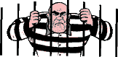
AT WORK... you spend the majority of your time in a 6X8 cubicle.

IN PRISON... you get three meals a day;
AT WORK... you only get a break for one meal

and you have to pay for it.

IN PRISON... you get time off for good behavior;

AT WORK...you get rewarded for good behavior with more work.
IN PRISON... the guard locks and unlocks all the doors for you;
AT WORK... you must carry around a security card

and open all the doors for yourself.

IN PRISON... you can watch TV and play games;

AT WORK... you get fired for watching TV and playing games.

IN PRISON... you get your own toilet;

AT WORK... you have to share

IN PRISON... they allow your family and friends to visit;
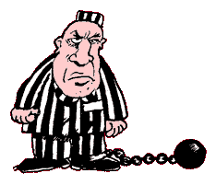
AT WORK... you can't even speak to your family.

IN PRISON... all expenses are paid by the tax-payers with no work required;

AT WORK... you get to pay all the expenses to go to work

and then they deduct taxes from your salary to pay for prisoners.

IN PRISON... you spend most of your life looking
through bars from inside wanting to get out.
AT WORK... you spend most of your time wanting
to get out and go inside bars.

IN PRISON... there are wardens.

AT WORK...they are called managers.

But cheer up, because
IN PRISON... you have to stay all the time.

AT WORK...you get to go home sometimes.

